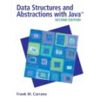 COSC 2320
Name: _________________ Terminal #__

Programming Assignment 3 JAVA Acceptance Testing:
Downloaded your zipped project from BB Assignment PROGRAMMING ASSIGNMENT 3 on your DESKTOP under FOLDER PA3.
Open it using NetBeans 6.9.1 (ONLY).
Download from BB Assignment TESTING PROGRAMMING ASSIGNMENT 3 on the “Programming Assignment 3 Acceptance Testing.doc” on your DESKTOP under FOLDER PA3.
Run the following test cases using the NEW “Programming Assignment 3 Data.txt” Data file provided in BlackBoard, take screenshots of the project output (see template), and insert in this file.

1. Screenshot of the time stamps for your files once you have downloaded them on the DESKTOP, folder PA3 (list details):
…….
Screenshot should look like this (replace this with your own screenshot):
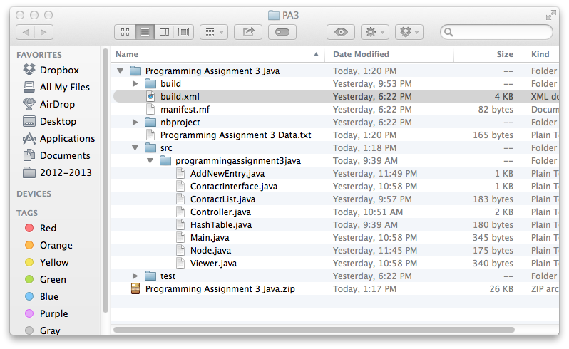

2. Include your UML USE CASE Diagram MODEL (step 3 ONLY):
…….
Screenshot should look like this (replace this with your own screenshot):
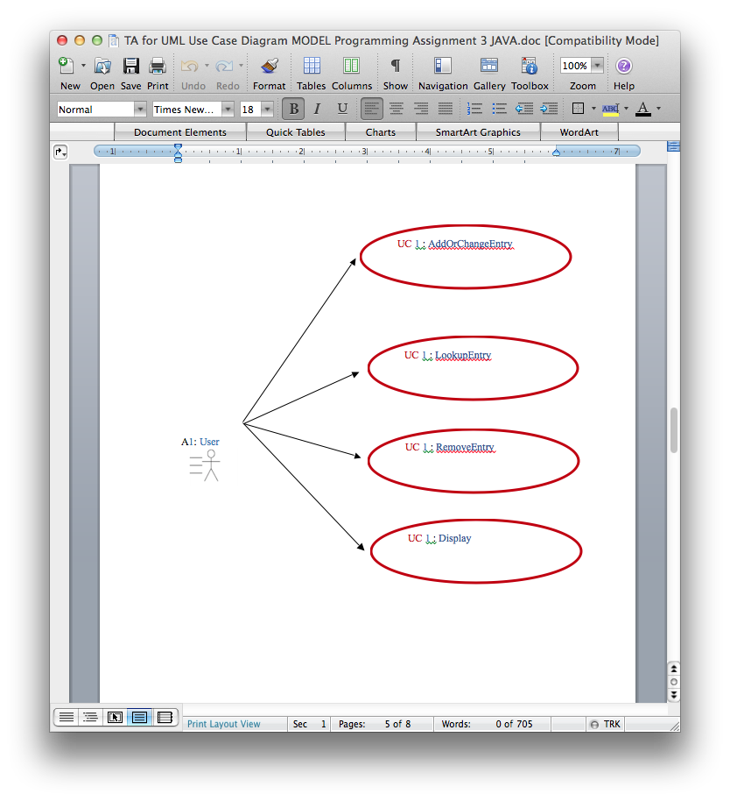

3. Include your UML MVC CLASS Diagram MODEL (step 4 ONLY):
…….
Screenshot should look like this (replace this with your own screenshot):
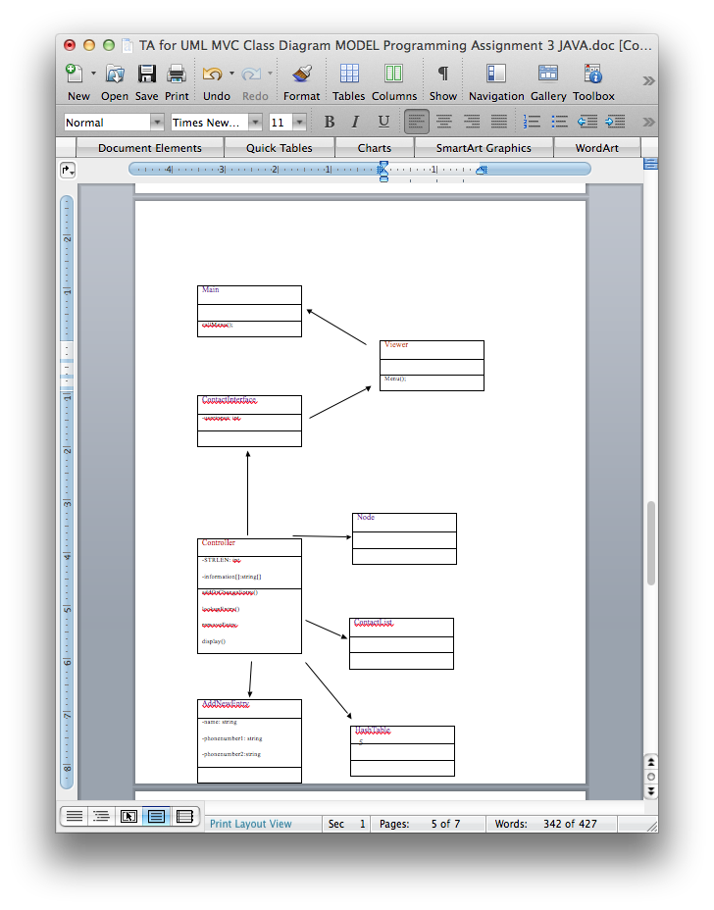
4. Copy and paste the contents of “Programming Assignment 3 Data.txt”:
SCREENSHOT showing the input is:

Brave Balto: 415-782-5555, 610-555-4820
Bash Bashfull: 212-782-8000, 215-555-1234
Donald Duck: 622-873-8920, 715-666-1234
Goof Goofy; 215-782-9000, 818-999-1111

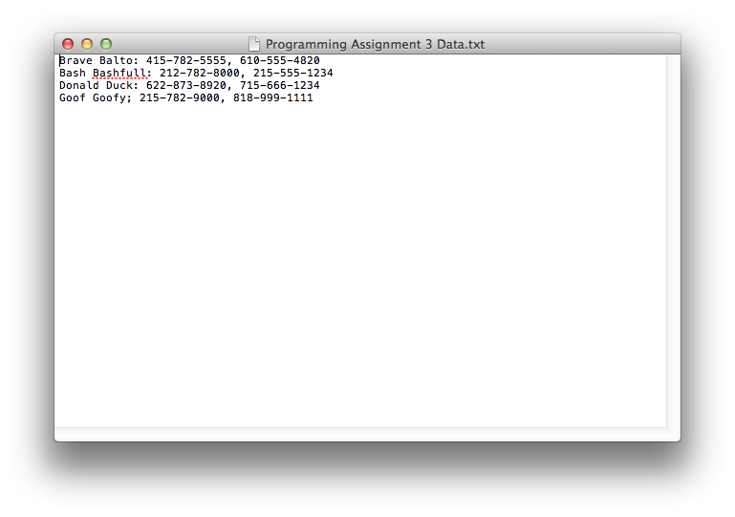

5. Lookup for Donald Duck:
PROJECT SCREENSHOT showing the ProgramingAssignment3 first 4 lines of comments in the source window and the output is:
……..
Screenshot should look like this (replace this with your own screenshot):
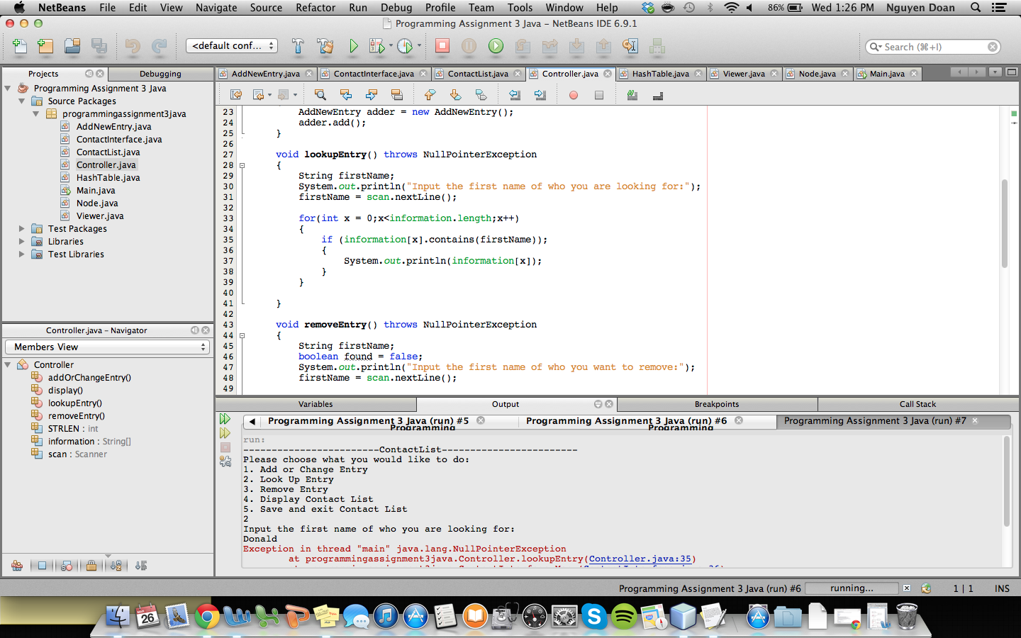

6. Lookup for Victoria Hilford:
PROJECT SCREENSHOT showing the lookup source and the output is:
……..
Screenshot should look like this (replace this with your own screenshot):
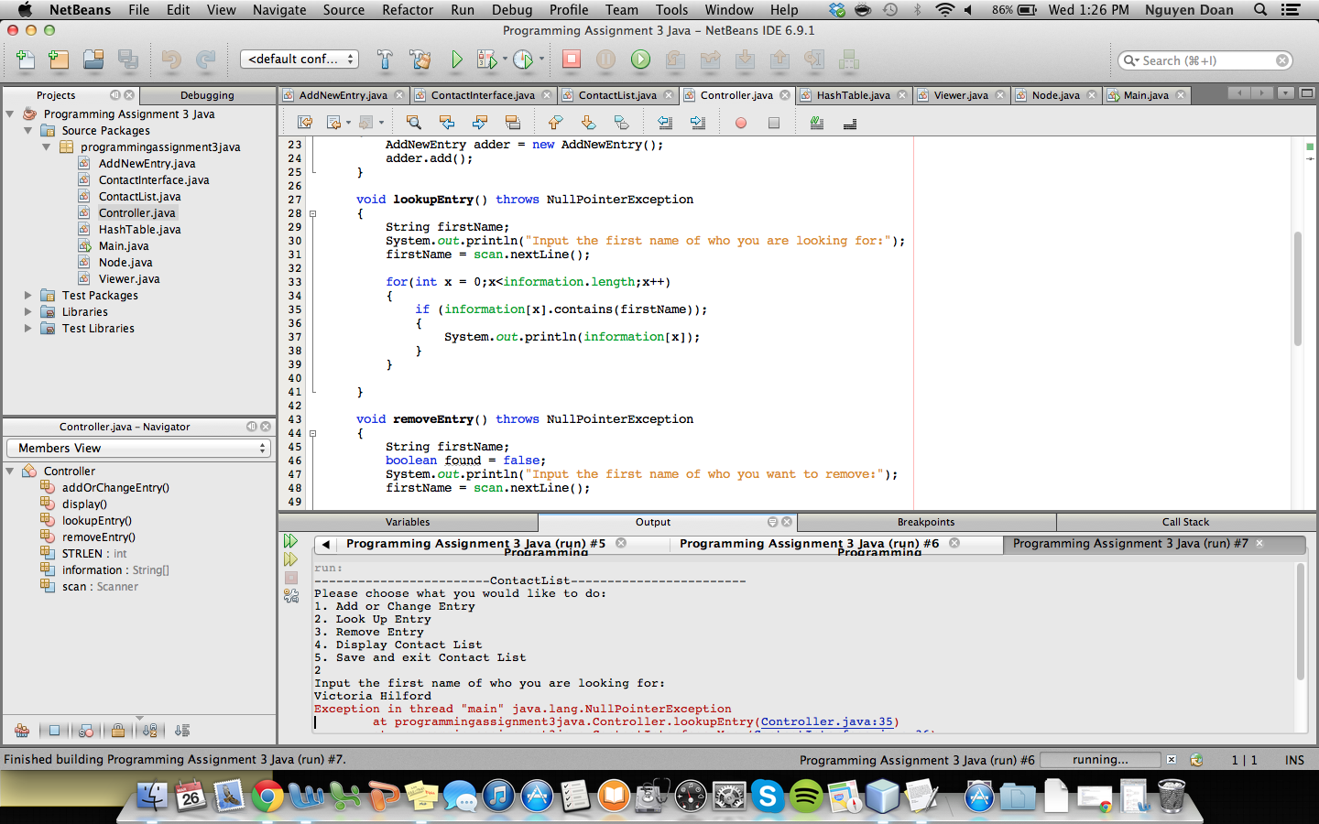

7. Display:
PROJECT SCREENSHOT showing the display source and the output is:

……..
Screenshot should look like this (replace this with your own screenshot):
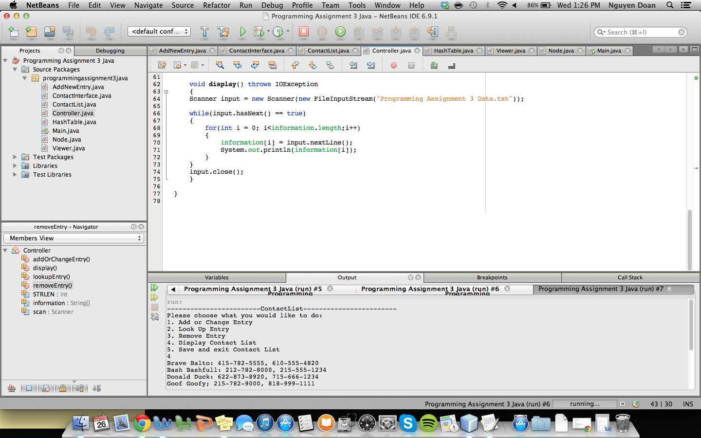

8. Add Victoria Hilford: 111-11-1111, 222-22-2222:
PROJECT SCREENSHOT showing the add source and the output is:
……..
Screenshot should look like this (replace this with your own screenshot):
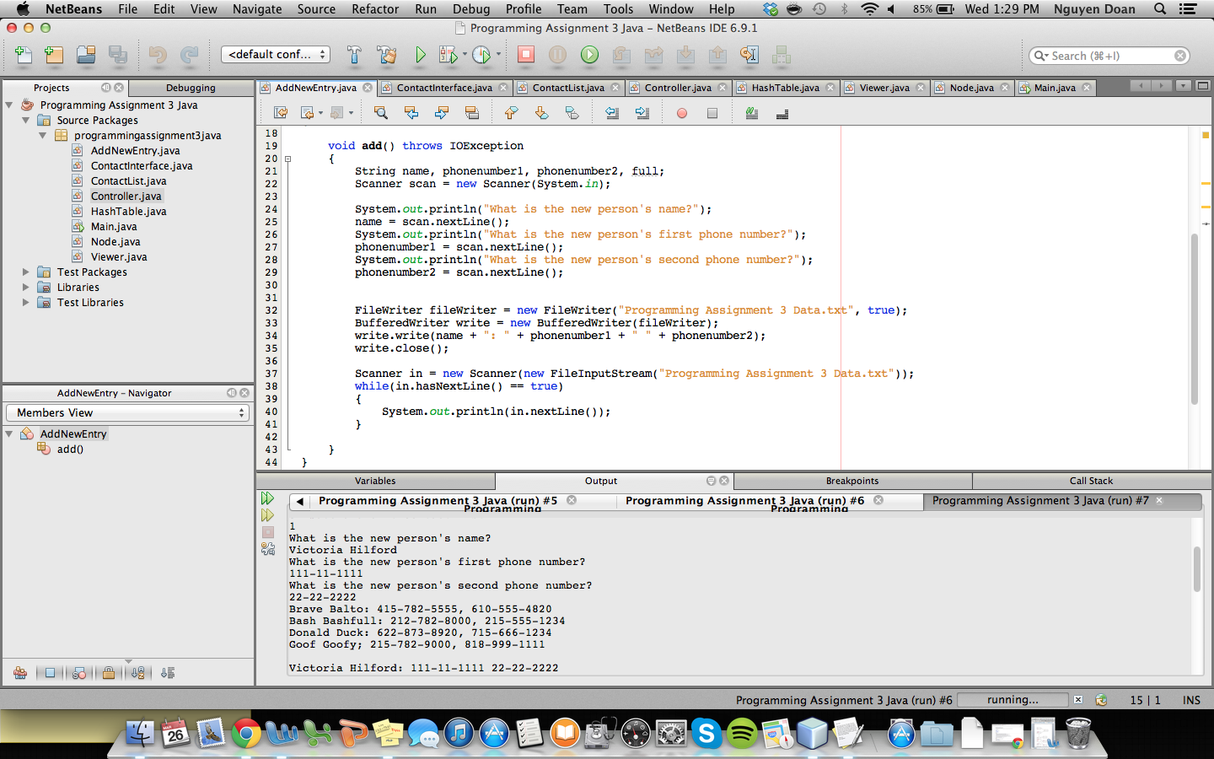

9. Display:
PROJECT SCREENSHOT showing the load data source and the output is:

……..
Screenshot should look like this (replace this with your own screenshot):
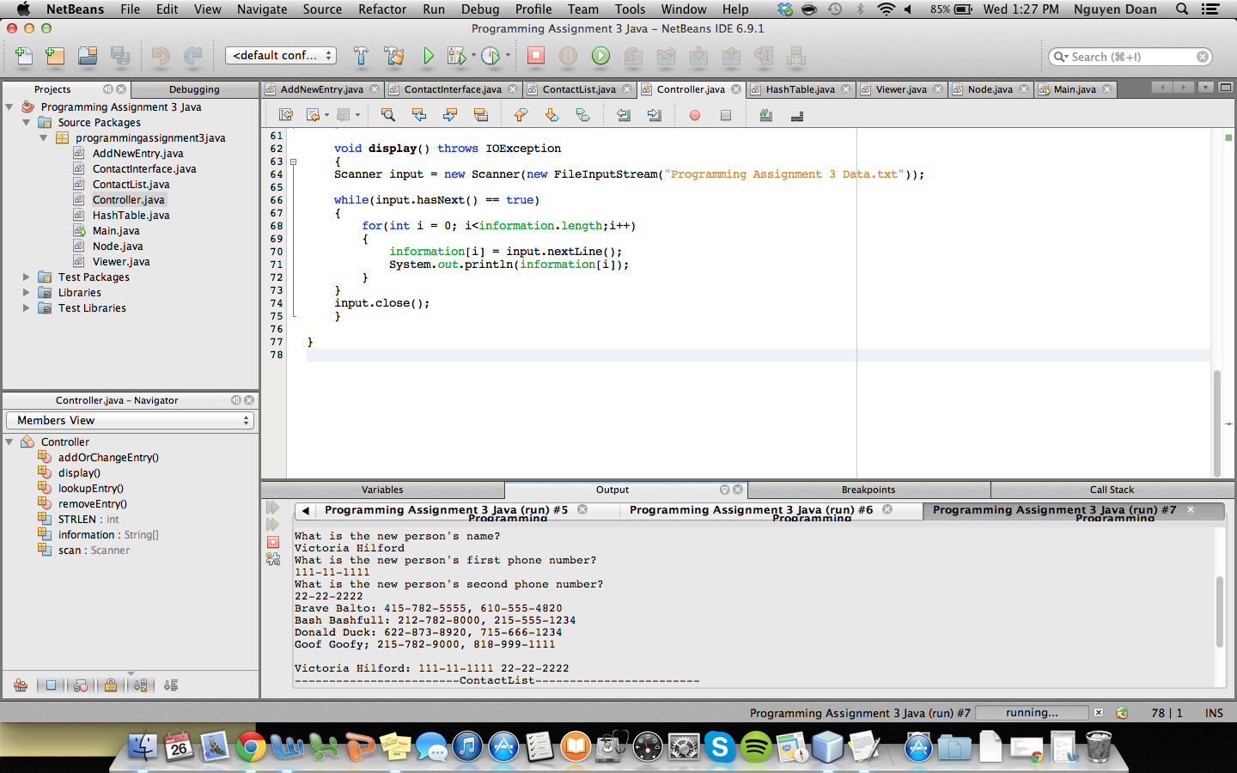

10. Remove Donald Duck:
PROJECT SCREENSHOT showing the remove source and the output is:

……..
Screenshot should look like this (replace this with your own screenshot):
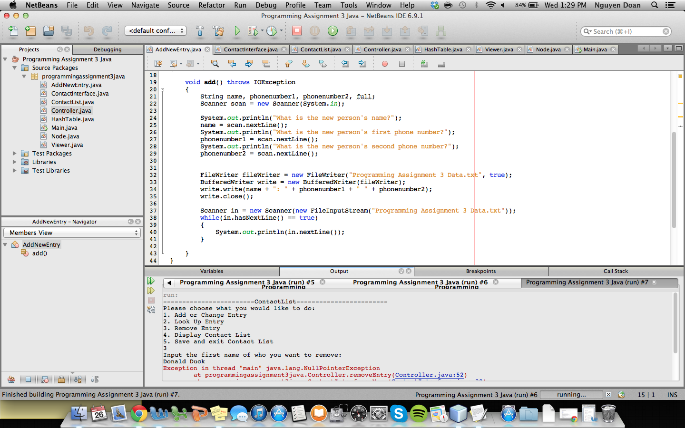

11. Screenshot of the time stamps for your files once you have downloaded them on the DESKTOP, folder PA3 (list details):
…….
Screenshot should look like this (replace this with your own screenshot):
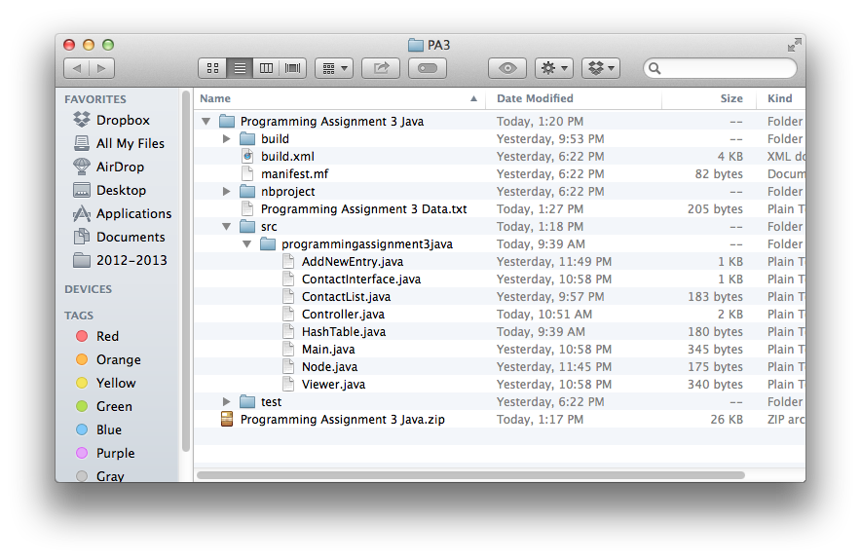

12. Copy and paste the contents of “Programming Assignment 3 Data.txt”:
SCREENSHOT showing the output is:

Brave Balto: 415-782-5555, 610-555-4820
Bash Bashfull: 212-782-8000, 215-555-1234
Donald Duck: 622-873-8920, 715-666-1234
Goof Goofy; 215-782-9000, 818-999-1111

Victoria Hilford: 111-11-1111 22-22-2222
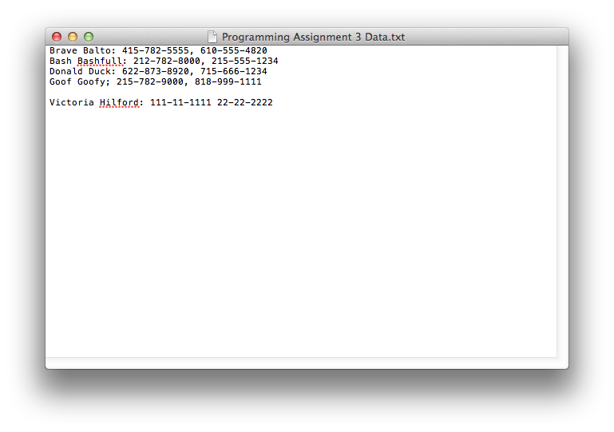
When done attach this file to “Testing Programming Assignment 3” BB assignment.

